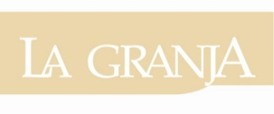
Secction (Check)
Scientific article ___
Review___
Point of View ___

English Title: Arial 14, bold and centered. Maximum 80 characters with spaces
Spanish Title: Arial 14, bold and centered. Maximum 80 characters with spaces

ABSTRACT
Maximum extension of 250 words. Abstract will be described in a concise way implicitly or explicitly and in this order: 1) Justification of the topic; 2) Objectives; 3) Materials and Methods; 4) Main Results; 5) Main Conclusions. It must be impersonally written: "This paper analyzes ..."

RESUMEN
Maximum extension of 250 cursive words. Abstract will be described in a concise way implicitly or explicitly and in this order: 1) Justification of the topic; 2) Objectives; 3) Materials and Methods; 4) Main Results; 5) Main Conclusions. It must be impersonally written "This paper analyzes ...". In the case of the abstract, automatic translation programs must not be used for the abstract.

KEYWORDS
Keywords: Between 4 and 6 keywords directly related to the subject of the work.

PALABRAS CLAVE
Keywords: Between 4 and 6 keywords directly related to the subject of the work.

FINANCIAL SUPPORT AND AUSPICIE OF RESEARCH (Optional)
Entity:
Country:
City:
Subsidized project:
Project code:

